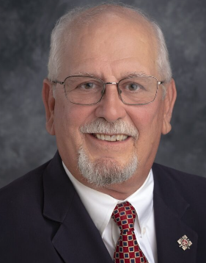**Illinois Firefighters Pension Investment Fund (IFPIF)**

**Greg Knoll, IFPIF Beneficiary Trustee**

It was a pleasure to see familiar faces on-line at the April meeting and in person at the picnic meeting in Dunlap. For those of you who made time to attend a meeting, this article may contain information you have already heard.

The IFPIF accounting fiscal year ends on June 30. The 2023-2024 fiscal year preliminary performance report shows a 13.0% rate of return. Another good performance year thanks to the staff, advisors, and investment managers at the fund.

The figures shown below are net of all investment fees.

Shown below is the preliminary IFPIF total account balance as reported by Marquette. Keep in mind that this total does not include any money kept at the local fund level to pay benefits and expenses of a local board.

Go to IFPIF’s web site (<https://ifpif.org/>) if you want to:

- check the calendar for upcoming meetings  - review approved minutes from any meeting

- see an agenda for any upcoming meeting - see quarterly investment reports

- see Annual Comprehensive Financial Reports - look up statements for your local fund

***Go to the web site and sign up for the newsletter*.**

If you have any questions or want to know more, text/call me at 708-296-9160 or e-mail me at:  [gknoll@ifpif.org](mailto:gknoll@ifpif.org)

*Be smart, be safe, and take care of your partners. Have fun and enjoy your hard-earned retirement.*